System Architecture of TAX AI application
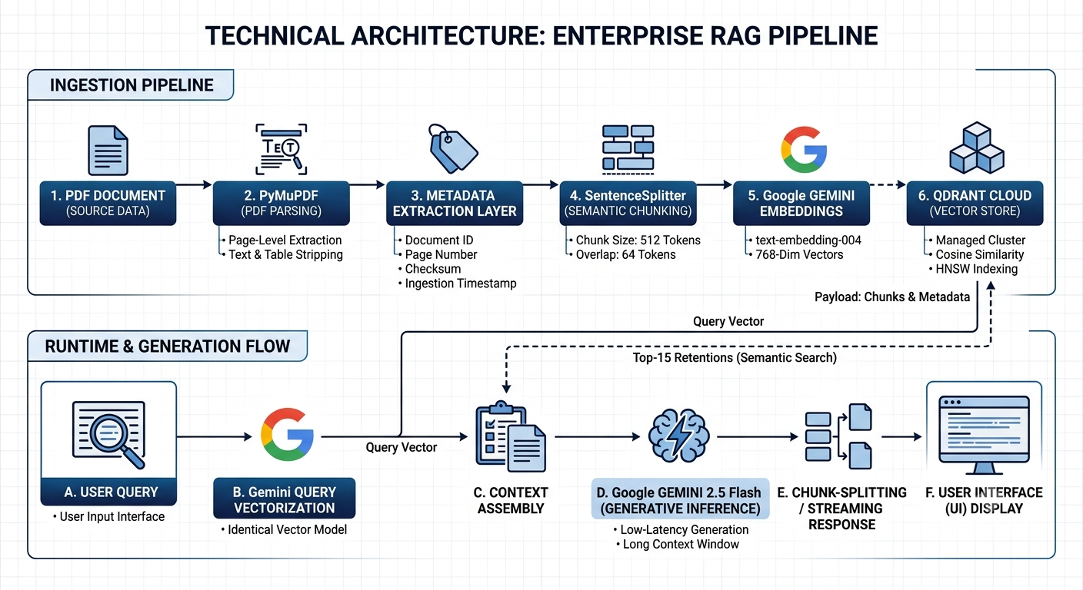

Tech Stack

- Python
- HTML,CSS,JS
- Flask
- Qdrant-VectorDB
- GEMINI – AI model
- LangChain

How This RAG System Works
1. Document Ingestion (ingest.py / POST /api/v1/ingest)
- PDF Parsing — PyMuPDF (fitz) reads each page of every tax act PDF, extracting raw text page by page
- Metadata Extraction — Filename is regex-parsed to pull out: tax type (VAT, NBT, IRA, etc.), act number, year, whether it's an amendment or consolidation
- Section Detection — Each page's text is scanned for patterns like Section 25A, PART III, Schedule II to tag the legislative location
- Rate Extraction — Percentages like 18% or 15 per cent are found and stored as metadata flags
- Chunking — LlamaIndex's SentenceSplitter breaks pages into 1024-token chunks with 200-token overlap, respecting sentence boundaries so no sentence is cut mid-way
- Embedding — Each chunk is sent to Google's gemini-embedding-001 model, producing a 3072-dimension vector
- Storage — Vectors + full metadata are uploaded to Qdrant Cloud in batches of 300

2. Vector Store Schema (Qdrant)
- Each stored point contains: the embedding vector + a metadata payload (act name, tax type, year, section, page number, tax rates found, etc.)
- 6 payload indexes are created for fast pre-filtering: tax_type_code (keyword), act_number (keyword), year (integer), tax_type (keyword), has_tax_rates (bool), section (full-text)
- Distance metric: cosine similarity

3. Query Processing (query_tax_advisor() in rag_engine.py)
- User's query text is embedded using the same gemini-embedding-001 model
- Qdrant performs cosine similarity search, retrieving the top 15 most relevant chunks (high k to ensure all applicable tax types are covered — a single scenario like "importing shoes" can touch VAT + SSCL + NBT simultaneously)
- Retrieved chunks are formatted into a structured context string, each labelled with its source act, tax type, section, page, and any rates found

4. LLM Response Generation (Gemini 2.5 Flash via LangChain)
- A system prompt instructs the model to act as a Sri Lankan tax advisor — identify ALL applicable taxes, quote exact rates and section references, consider amendments, and flag exemptions
- The human prompt injects the user's query + the 15 retrieved chunks as legislative context
- Temperature is set to 0.1 (near-deterministic) for factual accuracy
- The LLM response is structured with a ===DETAILED=== delimiter, which the code splits into:
  - Summary — 3–6 bullet points with rate, act, section, effective date
  - Detailed Analysis — full markdown breakdown per tax type

5. Source Attribution
- After the LLM call, the 15 retrieved documents are deduplicated by (act_name, section, page) and returned as sources — each with act name, tax type, year, section, page number, and a 500-character content preview
- The UI displays these as collapsible source cards with colour-coded tax type badges

6. Upload Flow (new feature)
- A PDF is uploaded via POST /api/v1/upload → saved to a temp file using the original filename (so metadata extraction from the filename still works) → runs through the same parse → chunk → embed → ingest pipeline → temp file is deleted → chunk count returned to the UI

